Off to the Races! (2 week unit)

Learning Target – I can mesh two or more gears of different sizes to create greater torque or speed by building a drag racer, snail racer, or up-hill climber.

Students will build a robot to participate in one of three competitions: the drag race, the snail race, or an uphill climb.

The instructor can limit parts based on his/her inventory as long as all students are starting with an equal playing field.

Day 1 – Introduce the concept of gear ratios by giving students LEGOS and showing them how to assemble the following meshed gears: a #15 beam with a 40 tooth gear and an 8 tooth gear meshed together on it. (Use the tan, not blue, half pin-half axles pieces, they have much less friction than the blue ones.)

As in the first week’s lesson comparing the black and grey pins, students should use observation and manipulation to learn what is going on with the gears. The students should be able to comment on and demonstrate the following by the end of the day:
Big lead gear meshed with small follower equals increase in , small lead speed; small lead gear meshed with big follower equals increased torque (turning power).
Idler gears help change direction, but don’t change the output of the gear chain, except to increase friction if you have too many of them.

Day 2 – Show students video of robots using gear ratios. http://www.youtube.com/watch?v=mRJH6p_5csY&list=PL511D549B5A259040&feature=plcp

Students must choose whether they want to participate in a snail race, drag race, or uphill climb. Students can start planning.

Days 3-7 – Students build and practice with their robots. Share rubric with students so they know the benchmarks for achieving mastery. The instructor may want to give students a number of examples of motors connected to meshed gears as this is difficult for some students to do at first.

***I use duct tape on my shop floor to outline the race tracks for the drag and snail races. If you teach in a regular classroom the tiles outside in the hallway are most likely 12” X 12”. For the uphill, I use a board against the handle of a drawer, and keep raising it to rest against a higher drawer handle to make it more difficult. Adjust your rubric for whatever heights you can easily make in your room.***
Day 8 – Competition!

Days 9-10 Show students how to calculate gear ratios. Students must create a presentation of their robots in action that accurately includes a calculation of the gear ratio they used. They can take digital pictures and include them in a power point, word document, google doc, etc., whatever format the instructor and students are comfortable with. The document should include a statement similar to the following:

We meshed a __________ tooth lead gear with a __________ follower gear. Our gear ratio was _______ : _______. This means for each turn of the lead gear, our follower gear turned ________ times. We increased torque/acceleration with our robot.

Have the students write out the equation they used to calculate the gear ratio.

***Gear ratios are intentionally calculated at the end, not the beginning of this unit. It has been my observation that students have an easier time understanding the math behind gear ratio calculations after having built their robot and competed in the competition.***

Standards for Unit Three

Ratios and Proportional Relationships - 7.RP

Analyze proportional relationships and use them to solve real-world and mathematical problems.
1. Compute unit rates associated with ratios of fractions, including ratios of lengths, areas and other quantities measured in like or different units. For example, if a person walks 1/2 mile in each 1/4 hour, compute the unit rate as the complex fraction 1/2/1/4 miles per hour, equivalently 2 miles per hour.
2. Recognize and represent proportional relationships between quantities.

Apply and extend previous understandings of operations with fractions to add, subtract, multiply, and divide rational numbers.
1. Apply and extend previous understandings of addition and subtraction to add and subtract rational numbers; represent addition and subtraction on a horizontal or vertical number line diagram.
a. Describe situations in which opposite quantities combine to make 0. For example, a hydrogen atom has 0 charge because its two constituents are oppositely charged.

R2 - Use gears to manipulate speed (acceleration) and power (torque).
A. Identify different types of gears and their uses: shaft, worm, rack and pinion, pulleys, bevel, crown, and spur.
B. Build various structures using different gears.
C. Mesh gears in a structure, horizontally, vertically, and diagonally.
D. Using meshed gears, increase the acceleration of a given drive train.
E. Using meshed gears, increase the torque of a given drive train.
F. Understand and explain the relationship between torque and acceleration.
G. Calculate the gear ratios of a given set of meshed gears.
H. Understand and explain the role of friction in a gear train, including the use of idler gears.
I. Build and calculate the gear ratio of a cascading gear train.
J. Distinguish between input (lead), output (follower), and idler gears.

ETS1.A: Defining and Delimiting an Engineering Problem
ETS1.B: Developing Possible Solutions
ETS1.C: Optimizing the Design Solution

Name _______________
Date_________________
Period _______________

My Robotics Journal – Unit 3 – Off to the Races!

Learning Target –

1. During this last project I …

2. Some new pieces I learned during this project were …
(write names of pieces and tell what they were used for if you can, or you can draw as well)

3. I learned a new technique for building, it was …

4. Three gear ratios we tried that we did not choose in the end were…

5. One thing I did to help my gears mesh smoothly was…

6a. My partner(s) and I were successful during this project because …

OR
6b. My partner(s) and I were unsuccessful during this project because …

7. One thing I wish the teacher had done differently during this project is…

8. One thing I would do differently during this project is…
Introduction to Robotics
Unit 3 – The Timer

After running robot drag races for several years in a row, I have come to the conclusion that it’s nearly impossible to get an accurate time with a stopwatch or a smart phone. As the difference between Mastery and Beyond Mastery (not to mention fastest in class) is only a few tenths, sometimes hundredths, of a second, this becomes a very important matter.

There are several methods for creating an accurate timer. This document will describe one with a variation.

Method One – All students set their drag racers to go when they hear a loud sound. Programmatically this would utilize a Wait for Sound icon set to trigger at >100.

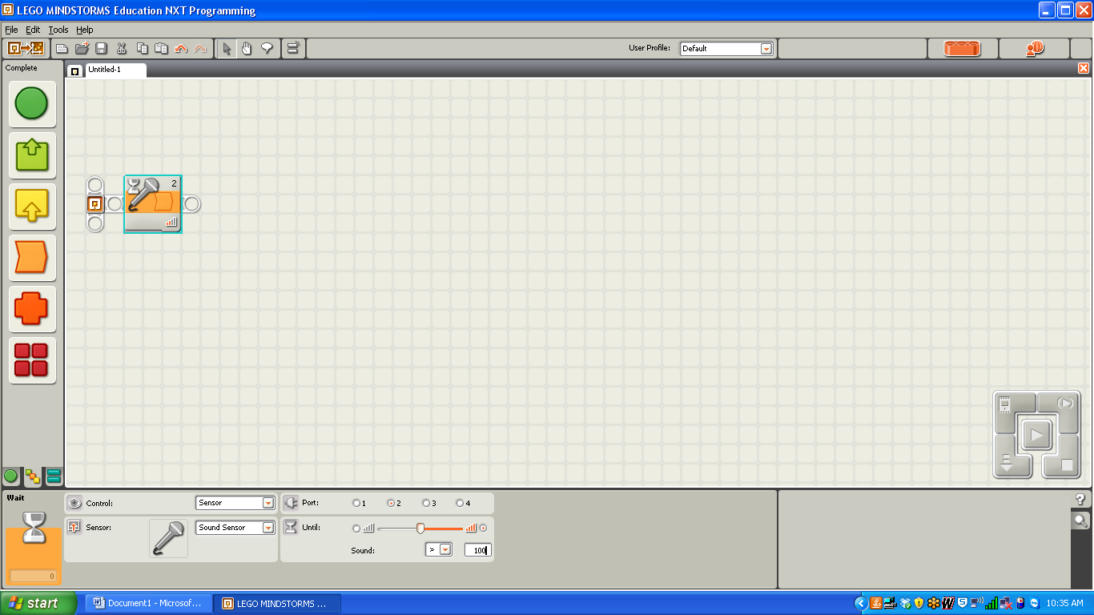

After the Wait for Sound the students can then program their robots to go forward at whatever power level they choose for whatever duration will get them to the finish line.

Concurrently the teacher will set up a “Timer Bot” at the finish line. This robot will lay on the ground with a sound sensor attached and an ultrasonic sensor pointing forward across the finish line. On the opposite end of the finish line you will need a board, wall, or some solid object the ultrasonic sensor can sense.

The Timer Bot will wait for a loud sound, start counting, wait for a robot to cross its path, finish counting, then display the time.

In Psuedo Code – Reset Timer, Wait for Loud Sound, Start Timer, Wait for Distance less than distance to wall or other object across the finish line, stop timer, display time.
Programmatically it looks like this:
Display Time
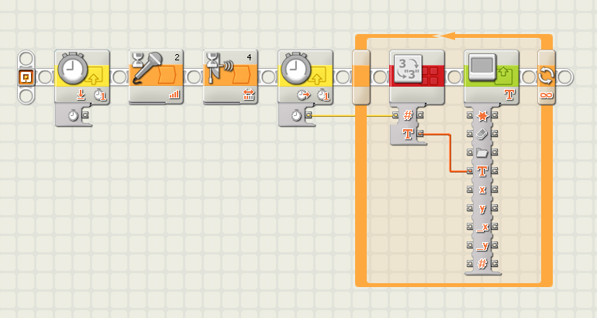
Wait for Sound
Reset Timer
Wait for Distance
Read Timer

Variation – Students can use Bluetooth to communicate to the Timer Bot when their robot is starting, and the Timer Bot can start its timer at that point. To stop, the drag racer can use a light sensor to indicate when it’s crossed the finish line and send another Bluetooth signal to the Timer Bot to stop timing.

Note – the timer will relay time in milliseconds.
Unit 3 Rubric - Off to the Races
 | A - Above Mastery | B - Mastery | C - Approaching Mastery | I - Incomplete
Drag Race | 20 ft. in 3 seconds or less | 20 ft. in 3.001 to 5 seconds | Robot has two gears meshed in the correct way (to increase accleration) but was not able to complete drag race in under 5 seconds or at all (went off course). | Robot not finished.
Snail Race | Took longer than 3 minutes to travel 2 ft. | Took between 2 and 3 minutes to travel 2 ft. | Robot has two gears meshed in the correct way (to increase torque/decrease acceleration) but finished snail race very quickly (under3 minutes) or not at all. | Robot not finished.
Uphill Competition | Travelled up a 60 degree inclined ramp for at least 3 ft. | Travelled up a 50 degree inclined ramp for at least 3 ft. | Travelled up a 40 degree inclined ramp for at least 3 ft. | Robot not finished.
Gear Ratio Calculation | Document clearly shows picture of robot with gears labelled, gear ratio calculated, and explained using appropriate terminology. | Document is complete, gear ratio is calculated but explanation may not be totally accurate or use right terminology, gears may not be labelled well. | Gear ratio is calculated but document is not complete or is completely lacking in depth of explanation/diagram. | Gear ratio is not accurate.

