Introduction to Programming
Lego Mindstorm EV3
Behaviors: Sensors – Move Until Color 1-5 & C
(found online in Robotics Academy EV3)

❐ Watch Color 1: Introduction to Autonomous Vehicle
1. What are some of the challenges a self-driving car must overcome?
- Finding a path to the destination
- Following the road
- Obeying traffic laws and signals
- Avoiding other vehicles
- All of the above

2. What will the robot need to detect with the Color Sensor?
- The speed of the robot
- Distance from the vehicle in front of the robot
- Width of the road
- Color of a traffic light

❐ Do Gyro 2: Robot Configuration
Configure Color Sensor to Robot per instructions.

❐ Watch Color 3: Wait for Green
1. What does this program do?
- Wait for the Color Sensor to see a Red object, then move forward
- Wait for the Color Sensor to see a Green object, then move forward
- Wait until an object is moved out of the way, then move forward
- Move forward until it sees a Green object
Page 2
Page 1

2. When multiple colors are checked in the "Set of Colors" area, what will the Wait Block do?
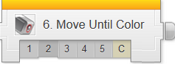
- Wait for ANY of the colors to be seen
- Wait for ALL of the colors to be seen at the same time
Check the boxes ✓ as you finish each task.
- Wait for ALL of the colors to be seen at least once each
- Wait for ALL of the colors to be seen in the order indicated by the numbers

The EV3 Color Sensor can detect 7 different colors, plus the absence of color.
Each of these 8 colors is labeled with a different number.

❐ Do Try it! 1: No Color
What does the No Color "color" mean in the Set of Colors menu?
Change your program so that it waits for "No Color" (Option 0). Make sure you unselect all the other colors.

Place various objects in front of the Color Sensor, and run the program.
What triggers the Wait For No Color Block? Try it!

❐ Do Try it! 2: Port View: Color Sensor Values
You can see the Number value of the currently detected color directly on the EV3's view screen, in the Port View Mode.
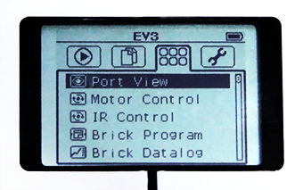
1. Use the Left and Right Buttons on the EV3 to navigate to the EV3 Apps menu (), and press the Enter Button to select 'Port View Mode'.

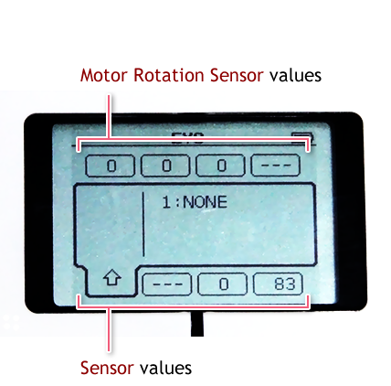
The 8 blocks at the top and bottom of the screen represent the 8 ports on the EV3.

- Motor Rotation Sensor values are displayed across the top.
- Sensor Values are displayed across the bottom, depending on what is plugged in.
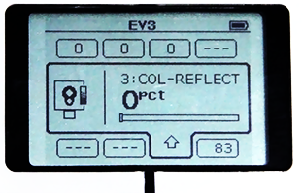
2. Use the Left and right Buttons so that the Color Sensor's Port View block is selected.

"COL-RELECT" means the sensor is reading amount of colored light being reflected.
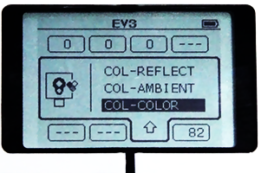
This is not what we want, since we want to see exactly what color the sensor is seeing, not the amount of color.

3. Press the Enter Button on your EV3 while the Color Sensor's Port View block is selected.
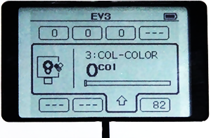
Move the Up and Down Buttons to select the type of reading 'COL-COLOR', and press the Enter Button to set new reading type.

4. Now the Color Sensor's Port View will display the color value. ('COL-COLOR')

1. Point the Color Sensor directly at the Red side of the Color Crate.
What value do you see?

2. What value should you see if the Color Sensor is pointed at the Blue side of the Color Crate?

3. Point the Color Sensor away from the Color Crate and any strong lights. What reading does it give?

❐ Do Mini Challenge 1: Railroad Crossing
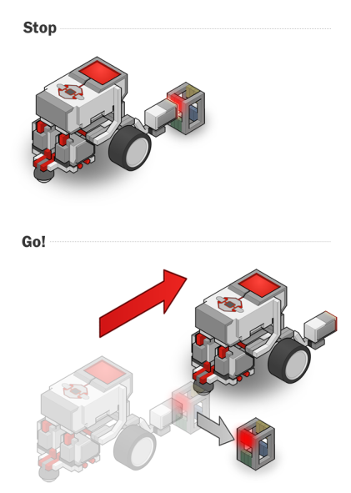
Instead of red and green lights, some traffic signals simply use signs that raise and lower in the path of traffic. Program your robot so that instead of waiting for a green light, it waits for the red stop sign to be taken away.

❐ Show Teacher: Railroad Crossing

❐ Watch Did you know? How the Color Sensor Works

❐ Watch Color 4: Forward Until Red

1. What does this program do when run?
- Move forward when the robot sees a red object
- Move forward until the robot sees a red object
- Move backward when the robot sees a red object
- Move faster when the robot sees a red object
Page 3
Page 4
❐ Do Mini Challenge 1: Forward To Stop Line
In addition to signs and lights, self-driving cars also need to obey pavement markings, like this stop line telling where to stop.

Modify your Color Sensor attachment, so that it faces downward,
and program your robot to drive forward until it reaches the line.

❐ Show Teacher: Forward Until Yellow (Yellow line on dark surface)
❐ Show Teacher: Forward Until Black (Black line on light surface)

❐ Color 5: Color Sensor Review
The program shown below is sample code for making your robot wait until it sees the color green. Provide a detailed explanation of how the program blocks work and how the robot responds.
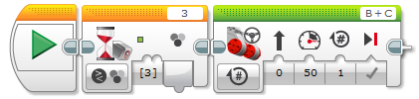

The program shown below is sample code for the Railroad Crossing mini-challenge. Provide a detailed explanation of how the program blocks work and how the robot responds.
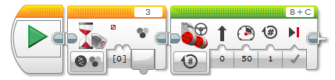
Page 5
Provide a detailed explanation of how the program blocks work and how the robot responds.
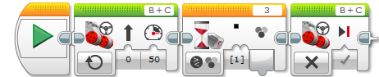

❐ Watch Color 6: Traffic Signal Challenge
❐ Do: Traffic Signal Challenge
In this challenge, you will program your EV3 robot to through three different intersections, each of which has a traffic signal. The traffic signal, which can be either the colored block or the red/green card, is held by hand at a set height. Unlike a camera, the detection range of the Color Sensor is short, so you will need to modify its placement on the robot so that it can see the traffic signal and react appropriately.

The robot does not need to stop on its own after passing through all three intersections (it can be stopped by hand).

Upon completion of the Behaviors-Move Until Color module 1-5 & C, you should have the following programs in a project titled “LastName_COLOR” (you should also update your program documentation file with a new slide titled COLOR SENSOR containing the programs, pictures and description for each maneuver):
❐ Wait Until No Color (Railroad Crossing)
❐ Forward to Yellow Line & Forward to Black Line
❐ Traffic Signal Challenge
Page 6
Page 4

