Introduction to Programming
Lego Mindstorm EV3
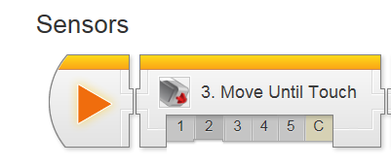
Behaviors: Sensors – Move Until Touch 1-5 & C (found online in Robotics Academy EV3)
Check the boxes ✓ as you finish each task.

❐ Watch Touch 1: Introduction
1. Why are sensors important to robots?
- They allow multiple commands to run in order
- They give the robot information about its surroundings
- They allow robots to repeat similar tasks
- All of the above

2. What is the advantage of Sensor Control over Sequential Commands?
- The robot can remember hazard areas
- The robot can perform actions a lot faster
- The robot can react to its environment
- There is no big advantage

❐ Touch 2: Configure Robot with Touch Sensor
❐ Watch Touch 3: Wait for Touch
1. What does the robot do when the WaitTouch program runs?
- Runs continuously until the Touch Sensor is pressed in
- Waits for 1 second, then moves 1 rotation
- Waits for the Touch Sensor to be pressed in, then moves 1 rotation
- Runs for 1 rotation

2. The program waits BEFORE it moves because...
- The Wait Block comes first in the program
- The Wait Block always takes priority over Move Blocks
Page 1 of 4
❐ Do Try it! 1: Already Pressed
What happens if you’re already holding down the Touch Sensor’s button when you start running the program?

❐ Do Try it! 2: EV3 Buttons
The 5 buttons on the front of the EV3 (not counting the Cancel button) can be used as Touch Sensors!
Try changing the Mode of the Wait Block to:
“Brick Buttons > Compare > Brick Buttons” and running your program.
Once it’s running, press the middle button on the front of the EV3!
What happens?

❐ Did you know? How the Touch Sensor Works
When the Touch Sensor is pressed, it ___________ an ____________ circuit, allowing current to flow.
If the Touch Sensor is released, the ____________ is _____________ and no _______________ flows.

The flow (or lack) of current is detected by the EV3, allowing it to determine the Touch Sensor is pressed.

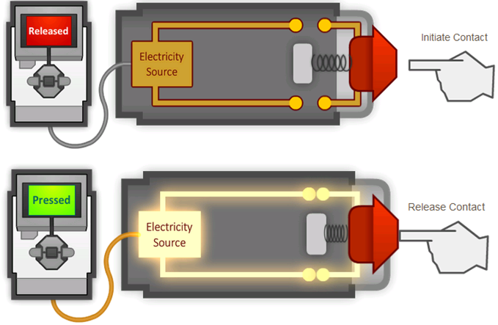
Page 2 of 4

❐ Watch Touch 4: Forward until Touch
1. What does a Move command do when its Mode is set to “On”?
- Turn the motors on
- Turn the motors on for a certain number of rotations
- Turn the motors on until the Touch Sensor is triggered
- Combines with the next block to make a special command

2. What does a Move command do when its Mode is set to “Off”?
- Turn the motors off
- Waits for the Touch Sensor to be pressed
- Wait for the Touch Sensor to be pressed, then turn the motors off
- End the program

❐ Do Try it! 1: Forward Until Release
The Wait - Touch block can wait for the sensor to be "Released" as well as "Pressed".
What happens if you set the Wait - Touch block to "Released" and run it with an empty box holding down the sensor?

❐ Do Mini Challenge 1: Vacuum  Teacher Sign-Off
Program the robot to touch all four walls of a room, using its Touch Sensor to know when it has reached each one.

❐ Touch 5: Touch Sensor Review
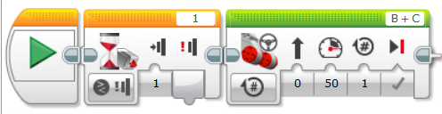
- Provide a detailed explanation of how the following program will run.

Page 3 of 4
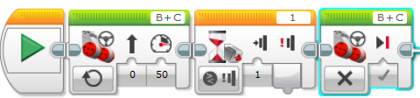
- Provide a detailed explanation of how the following program will run.

- Provide a detailed explanation of how the following program will run.
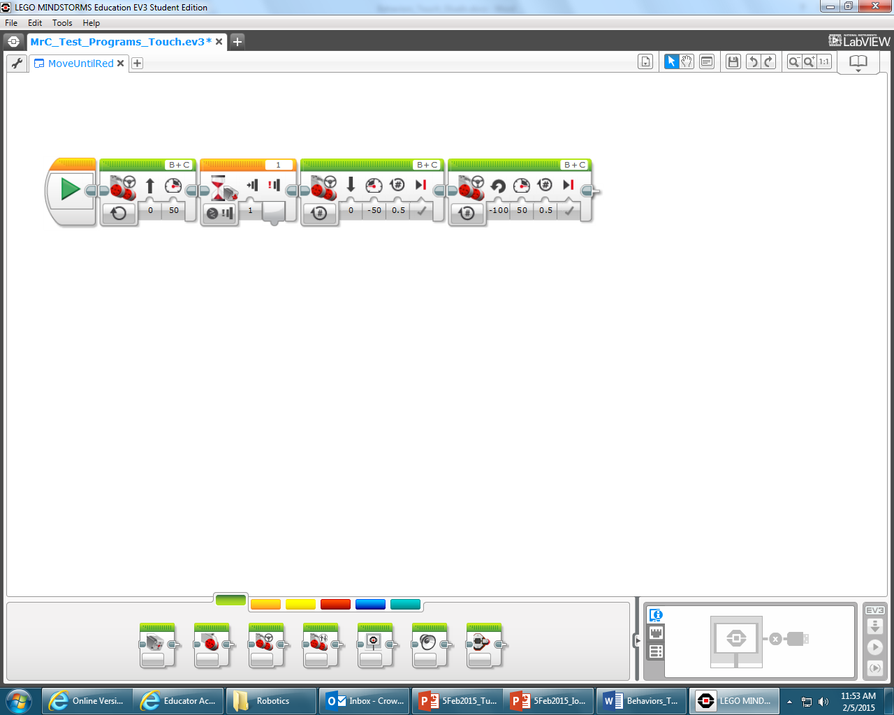

❐ Do Arm Position Challenge  Teacher Sign-Off
❐ Teacher Review of completed work.

Upon completion of the Sensors-Touch module 1-5 & C, you should have the following programs in a project titled “LastName_TOUCH” (you should also update your program documentation file with a new slide titled TOUCH containing the programs and description for each maneuver):
❐ from Try it! 2: EV3 Buttons program (with comments)
❐ from Try it! 1: Forward Until Release program (w/comments)
❐ from Mini Challenge 1: Vacuum program (w/comments & drawing)
❐ Arm Position Challenge program (with comments & drawing)

Page 4 of 4

