Introduction to Programming
Lego Mindstorm EV3
Behaviors: Moving Straight 1-5 & C (found online in Robotics Academy EV3)
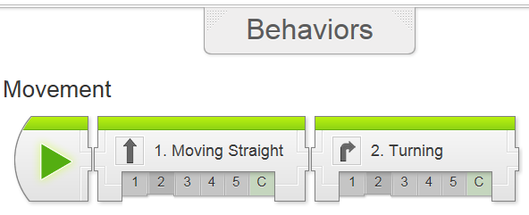
Check the boxes ✓ as you finish each task.
❐ Watch Moving Straight 1: Introduction with Sensabot
1. Why is it important to inspect industrial facilities often?
- Frequent inspections keeps facilities safe
- Problems are easier to fix if detected early
- Industrial facilities require inspections by law
- All of the above

2. What is the advantage of Sensabot over human inspectors?
- Sensabot can inspect much faster
- Sensabot can enter hazard areas
- Sensabot has wheels instead of legs
- There is no big advantage

3. In addition to basic movement, what specific skill will you need to complete this challenge?
- Operate the small motor (arm)
- Move a specific distance
- Control speed of the motors
- All of the above

❐ Moving Straight 2: Robot Config (build EV3 driving base with arm)

❐ Watch Moving Straight 3: Steering Forward (Name your new project, “LastName_MovingStraight”)

pg. 1 of 6
1. What does the robot do when the program is run?
- Move forward until its wheels have turned 1 rotation
- Move forward until its wheels have turned 3 rotations
- Move backward
- Turn to the left

2. How do you create a new program in the EV3 Programming Software?
- Click the + tab near the top of the screen
- Press the New Program button on the home screen
- Enter a name and press the Go >>> button
- Click the Quick Start button on the menu

3. How do you run a program that has been downloaded to the EV3?
- File > Run on the EV3 brick
- My Files > Software Files > Run on the EV3 brick
- "File Navigation" tab > Project name > Program on the EV3 brick
- Program can only be run from the PC or Mac

❐ Do Mini Challenge 1: 50 cm Challenge
❐ Observed by teacher ______________
❐ Add new slide in your “Program Documentation” titled MOVING STRAIGHT and add screen shot and description of program (50 cm Straight)

❐ Do Try It! #1: Brake vs. Coast
The last space on the Move Steering Block is for “Apply Brakes”.
What is the difference between the "Brake" and "Coast" settings for this option?

❐ Read/Review: Did you notice? Projects and Programs
❐ Read/Review: Did you notice? Rename Program
❐ Read/Review: Did you notice? Ev3 Menus
❐ Read/Review: Did you notice? Auto-detecting Ports
pg. 2 of 6
1. Which of the following is correct about the projects and the program inside it?
- A project can contain multiple programs
- A program can contain multiple projects
- Every project contains exactly one program
- Every project contains both programs and experiments

Fill in the boxes with the names of the EV3 menus:

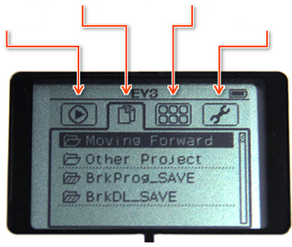
❐ Watch Moving Straight 4: Arm Control

1. What does the Medium Motor block do?
- Controls both of the large motors
- Controls the medium motor like the one on the arm
- Controls the ultrasonic sensor
- Controls all the motors

2. What happens when you use a negative power level?
- The motor runs backwards
- The robot moves faster
- The motor does nothing
- The program crashes
pg. 3 of 6
3. What happens when you put more than one block in a program?
- The program runs backwards
- The program runs in sequence
- The program doesn't run at all
- The program runs the largest motor block first

❐ Update “Program Documentation”, titled MOVING STRAIGHT, and add screen shot and description of program (Arm Control)

❐ Do Try It! 1: Negative Power
The Move Steering command also accepts negative power values to move backwards. Try entering -50 in the power blank on a Move Steering block. What happens?

❐ Do Mini Challenge 1: Cargo Retrieval
Program your robot to:
- Raise its arm
- Move 50cm to the box
- Drop the arm down
- Back up to robot's starting position with the box

❐ Cargo Retrieval Observed by teacher __________
❐ Update “Program Documentation”, titled MOVING STRAIGHT, and add screen shot and description of program and also a screen shot showing design of challenge (Cargo Retrieval)

❐ Read/Review Did you notice? Getting the Program Stuck

4. Does the program ever end?
- The program keeps running
- The program ends immediately

pg. 4 of 6
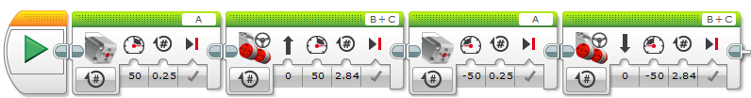
5. Does the second medium motor block ever get to run?
- The second motor block never runs
- The second motor block is skipped over

6. What happens if a block cannot complete its action?
- The program will immediately skip to the next block
- The program will try for a while, then display an error and quit
- The program will try for a while, then skip the "stuck" block and move on to the remaining commands
- The program will get "stuck" trying to complete the action, and later blocks will never be run

❐ Moving Straight 5: Moving Forward Review
How will the robot respond to the overall program shown above?

Provide a detailed explanation (block name, mode, inputs & how the robot will respond to this block).

Provide a detailed explanation (block name, mode, inputs & how the robot will respond to this block).

pg. 5 of 6
pg. 6 of 6

Provide a detailed explanation (block name, mode, inputs & how the robot will respond to this block).

Provide a detailed explanation (block name, mode, inputs & how the robot will respond to this block).

❐ Watch Moving Straight 6: Sensabot Challenge
❐ Do: Sensabot Challenge
❐ Show Teacher : Sensabot Challenge ___________

Upon completion of the Behaviors-Moving Straight module 1-5 & C, you should have the following programs in a project titled “LastName_MOVINGSTRAIGHT” (you should also update your program documentation file with a new slide titled MOVINGSTRAIGHT containing the programs, pictures and description of each maneuver):
❐ Straight Forward 50 cm
❐ Arm Control: Raise and Lower
❐ Cargo Retrieval
❐ Sensabot Challenge

