Introduction to Programming
Lego Mindstorm EV3
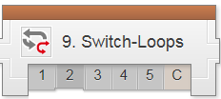
Decisions: Switch-Loops 1-5 & C (found online in Robotics Academy EV3)
Check the boxes ✓ as you finish each task.

❐ Watch: Switch-Loops 1: Introduction to Autonomous Tracker

What is the difference between this version of the Orchard Challenge and the original version in the Turning Chapter?
- There are more trees
- The robot must complete the challenge within a certain time limit
- There will be randomly placed obstacles in the robot's path
- There is no difference

❐ Do: Switch-Loops 2: Robot Config. (Ultrasonic Sensor)
❐ Watch & Do: Switch-Loops3: Obstacle Detection Failures
Why doesn't this program work for Obstacle Detection?
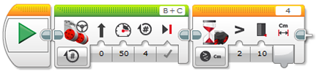
- The program detects an object and stops before moving all four rotations
- The program doesn't run because it's waiting to detect something in order to run
- The Move Steering Block holds up the program, preventing it from checking other sensors in the mean time
- All of the above are valid reasons on why the program doesn't work
Page 1 of 5
Page 2 of 5
Why doesn't this program work for Obstacle Detection?
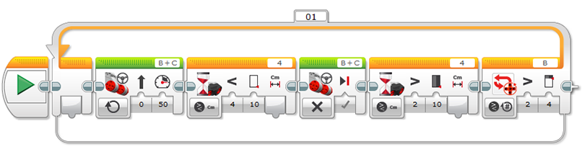
- The Wait Blocks prevents the flow from reaching the end of the loop and checking Rotation Sensors
- The program ends immediately when it detects an object, regardless of the Loop
- The Loop makes the robot go backwards
- The first Move Steering block only goes for one rotation, then ends the program

Instead of using Waiting approach and long movements, the solution you will learn next will involve:
- Rapid checking of sensors
- Sensor recombination fork
- A new multiple-sensor Wait Block
- A new type of Loop Block

❐ Watch & Do: Switch-Loops 4: Obstacle Detection
Instead of thinking about the four-rotation Obstacle Detection as one big movement, the video suggests thinking about it as...
- Using a brand new type of Wait Block that allows multiple sensor checking
- Downloading the program into the robot and using built-in options to run parts of the program at certain times
- A long series of tiny movements that add up for four rotations
- All of the above are valid suggestions

How do repeated decisions allow the robot to watch both sensors at once?
- The program resets and restarts at the beginning every time the readings of any sensor changes
- The robot calculates the path with both sensors at first and runs algorithms for the best way to run the course
- The robot activates a specific sensor at certain times throughout the course
- Every operation is fast, and does not block other commands from running

In the final version of the program, the robot ends up processing the Switch inside the Loop...
- Only once, ever, because it's a Switch
- Four times because the Loop goes for four rotations
- Thousands of times, because the robot processes the loop very quickly and encounters the Switch many times

❐ Do: Mini Challenge 1: Obstacle Detecting Move Until Black Line
Modify the Obstacle Detection program you wrote so that it will move safely (stopping when an obstacle is in front of it, moving when there is none) until the Color Sensor detects a black line on the table, rather than until the robot has traveled a certain number of rotations.
❐ Show Teacher ________________

Page 3 of 5
Page 4 of 5
❐ Program Review: Switch-Loops 5
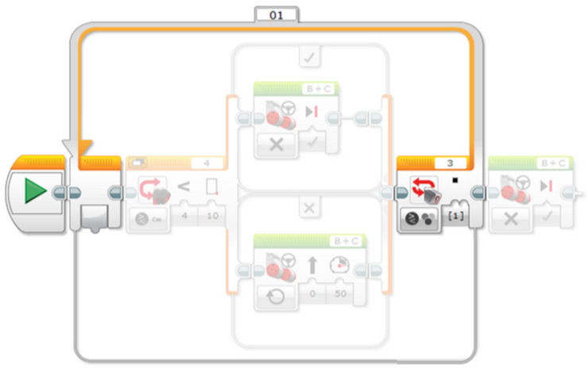
Provide a detailed explanation of the highlighted program block and how it will work.

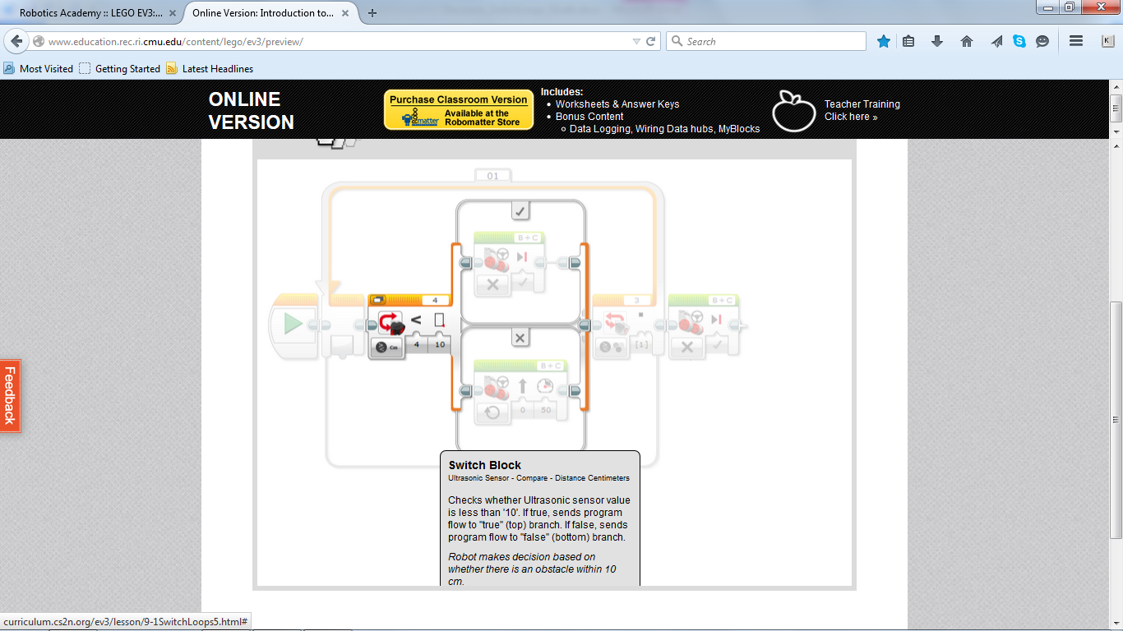

Provide a detailed explanation of the highlighted program block and how it will work.

❐ Watch & Do: Switch-Loops 6: Obstacle Orchard Challenge
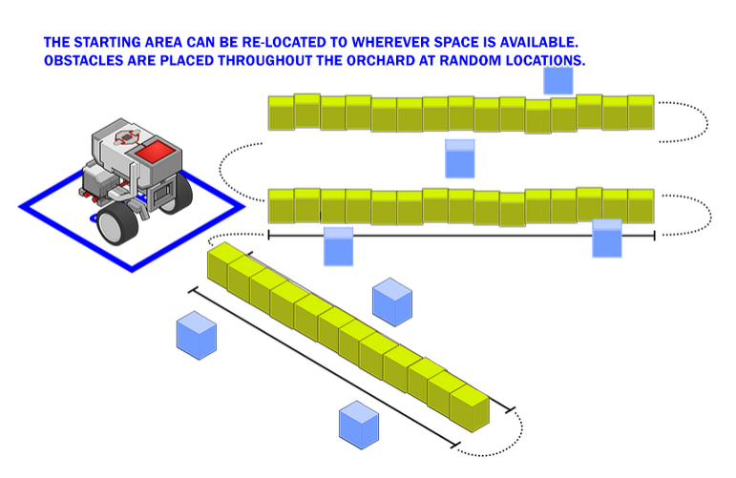

❐ Show Teacher ________________

Upon completion of the Decisions-Switches module 1-5 & C, you should have the following programs in a project titled “LastName_SWITCHES” (you should also update your program documentation file with a new slide titled SWITCHES containing the programs, pictures and description for each maneuver):

❐ Obstacle Detection: Move Until Black
❐ Obstacle Orchard Challenge

Page 5 of 5
❐ Watch & Do: Switch-Loops 6: Obstacle Orchard Challenge

❐ Show Teacher ________________

Upon completion of the Decisions-Switches module 1-5 & C, you should have the following programs in a project titled “LastName_SWITCHES” (you should also update your program documentation file with a new slide titled SWITCHES containing the programs, pictures and description for each maneuver):

❐ Obstacle Detection: Move Until Black
❐ Obstacle Orchard Challenge

Page 5 of 5

