Introduction to Programming
Lego Mindstorm EV3
Decisions: Switches 1-5 & C (found online in Robotics Academy EV3)
Check the boxes ✓ as you finish each task.
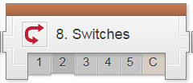

❐ Watch: Switches 1: Introduction to Strawberry Plant Sorter

A Switch will allow your robot to…
- Write very long programs
- Write multiple programs
- Repeat behaviors within a program
- Make a one-time decision

❐ Do: Switches 2: Robot Config (Ultrasonic Sensor)

❐ Watch & Do: Switches 3: Move If Clear

The robot will move forward...
- if there is no object in front of the Ultrasonic Sensor when the program starts
- if there is an object in front of the Ultrasonic Sensor when the program starts
- if an object passes in front of the Ultrasonic Sensor at any time
- until an object passes in front of the Ultrasonic Sensor

The robot makes its decision about whether to move forward or turn...
- Once, when the Switch is reached in the program
- Once, when the Switch sees an object
- Continually while the program is running
- The robot always moves, no matter what

Page 1 of 6
❐ Do: Mini Challenge 1: Color Sensor Compare Switch
❐ Show Teacher: Mini Challenge 1: Color Sensor Compare Switch
(turn right if blue or white and turn left for any other color)

❐ Do: Mini Challenge 2: Color Name Reader
(Create a program that will say the name of the detected color ((white, blue, red, yellow, & black out loud, by playing the sound for that color word)

❐ Show Teacher: Mini Challenge 2: Color Name Reader

❐ Watch & Do: Switches 4: Looped Decision

What happens when you place a Switch inside a Loop?
- The robot runs in a circle until told to stop
- The robot makes a decision once, then repeats the result many times
- The robot makes a decision many times, taking whatever action is appropriate each time
- You cannot place a Switch inside a Loop

When a Switch is placed inside a Loop…
- Both the Switch and Loop operate normally, but the arrangement is useful
- The software interprets the Switch+Loop structure as a special construct
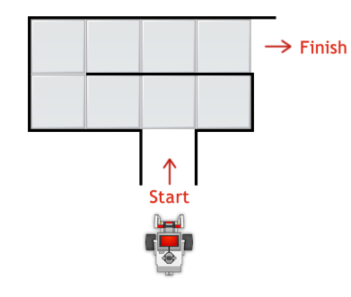
❐ Do Try It! 1: Maze Runner
Adjust your Forward movement to go one tile per movement, rather than 3 rotations.

What happens?

Page 2 of 6
❐ Do Mini Challenge 1: Smarter decisions challenge
❐ Show Teacher _____________

❐ Answer Switches 5: Switches Review [follow directions!!]
Start statements with “If” and “Then”, followed by statements starting with “If Not” and “Then”.

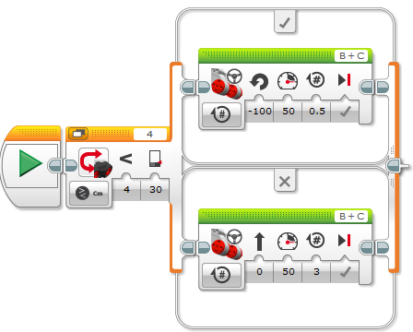
Explain, in detail, what the switch block shown will do.

Page 3 of 6

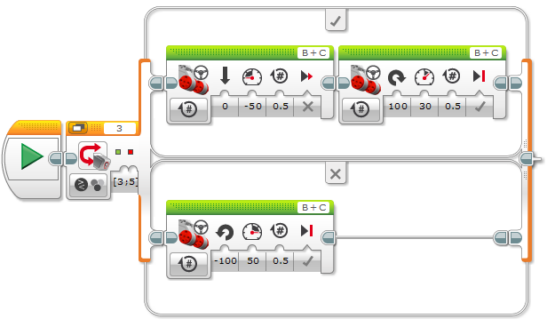
Explain, in detail, what the switch block shown will do.

Page 4 of 6
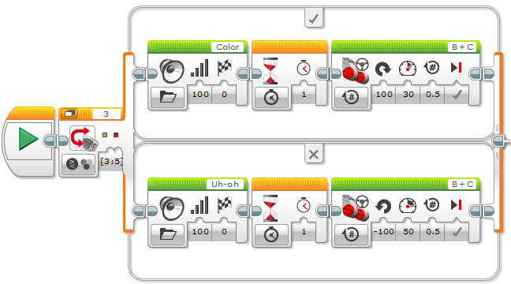
Explain, in detail, what the switch block shown will do.

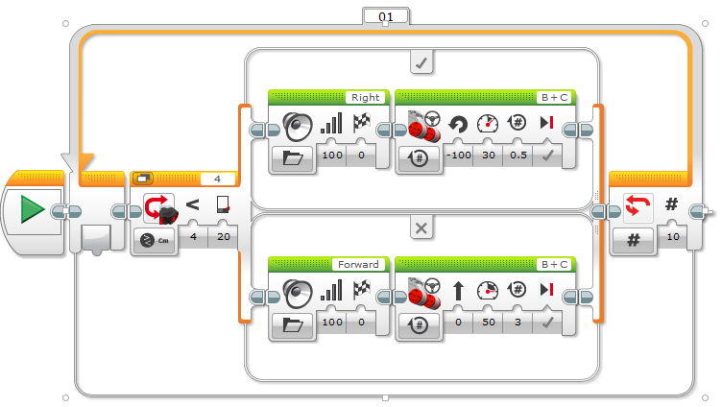
Explain, in detail, what the above program shown will do.

❐ Watch: Switches 6: Strawberry Plant Challenge
❐ Build: Switches 6: Robot Plant Sorter
❐ Do: Switches 6: Strawberry Plant Challenge
(Blue & White = Good plants. Red, Yellow & Black = Bad plants)
❐ Show Teacher _____________

Upon completion of the Decisions-Switches module 1-5 & C, you should have the following programs in a project titled “LastName_SWITCHES” (you should also update your program documentation file with a new slide titled SWITCHES containing the programs, pictures and description for each maneuver):
❐ Move If Clear  Color Sensor Compare
❐ Color Name Reader  Maze Runner
❐ Smarter Decisions  Strawberry Plant Challenge
Page 5 of 6
Page 6 of 6

