Introduction to Programming
Lego Mindstorm EV3
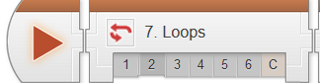
Decisions: Loops – Move Until Near 1-5 & C (found online in Robotics Academy EV3)
Check the boxes ✓ as you finish each task.

❐ Watch: Loops 1: Introduction to Container Handling Robot
1. Repetitive tasks can be accomplished efficiently by...
- Writing very long programs
- Writing multiple programs
- Repeating behaviors within a program
- Manually controlling the robot

❐ Do: Loops 2: Robot Configuration
❐ Watch: Loops 3: Looped Movement
1. What does the Loop do?
- Send the program "flow" back to an earlier point in the program, causing it to repeat some instructions
- Choose between two different possible sets of commands to run
- Repeat a branching decision quickly, to enable continuous control of the robot
- Run all the programs on the robot in a continuous cycle

2. How do you add a Loop to a program?
- Click the Loop Block, then drag a box around the commands you want to put inside the Loop
- Select the blocks you want to put inside the Loop, then right-click and choose "Place in Loop"
- Right-click in an empty area and choose "Make Loop" from the menu that appears
- Drag a Loop into the program, then drag commands into it
Page 1 of 5
❐ Do: Mini Challenge 1: Square Lap 1
Program a Looped behavior that makes the robot travel around a square box forever.

- How many complete loops did you succeed in completing before the robot went off course?

❐ Watch: Loops 4: Loop with Count Control
1. A Loop set to Count Mode will send the Program Flow back...
- Every time, forever
- Only a limited number of times
- If the Touch Sensor is not pressed when the Flow reaches the end of the Loop
- If there is nothing after the Loop

2. What does it mean for a Loop to be "Conditional" in the EV3 Programming Software?
- It only sends the Flow back under certain conditions
- The entire Loop can be skipped under certain conditions
- The Loop runs faster after it is trained, or "conditioned"
- The code runs every time, no matter what

3. What is the "condition" in this Loop based on?
- The distance the robot has traveled
- The value of the Touch Sensor
- The number of times the Loop has sent the Flow back
- The number of seconds the Loop has been running

❐ Do: Try it! 1: Other Counts
Try changing the number in the Loop's Count setting to 2, then running the program.
What happens?

❐ Do: Mini Challenge 1: Square Lap 2
Program your robot to make just one lap around the box (use a loop)
Page 2 of 5

❐ Watch: Loops 5: Loop with Sensor Control
1. When the Loop is set to Ultrasonic Sensor as shown below, what "condition" will cause it to pass Program Flow through (instead of sending it back)?
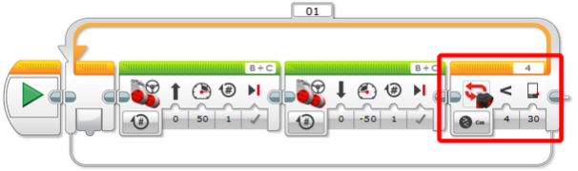
- The robot sees something within 30 centimeters immediately after moving forward
- The robot sees something within 30 centimeters immediately after backing up
- The robot sees something farther than 30 centimeters away
- The program repeats itself 30 times

2. If you want to make a Loop end based on a sensor reading, you should…
- Set the Loop's mode to "Sensor"
- Set the Loop's Mode to the sensor you want
- Select the sensor you want while the program is running
- Set the Loop's Mode to Count Sensors

3. When does a Sensor Loop check the sensor?
- Continuously while inside the Loop
- At the beginning and end of the Loop
- At the end of the Loop only
- At the end of every block within the Loop

Page 3 of 5

❐ Do: Try it! 1: Other Sensors
Set the Loop's mode to Touch Sensor instead of Ultrasonic Sensor. Make sure there is a Touch Sensor on the robot. Run the program and try to get the robot to stop!
What happens?

❐ Do: Mini Challenge 1: Square Lap 3
Make your robot run laps around the box until it encounters an obstacle in its way. The obstacle will be placed so that it is visible to the robot immediately after it turns.

❐ Show Teacher: Square Lap 3 _____

❐ Loops 6: Loop Review
Provide a detailed explanation of how the program runs AND how the robot responds.
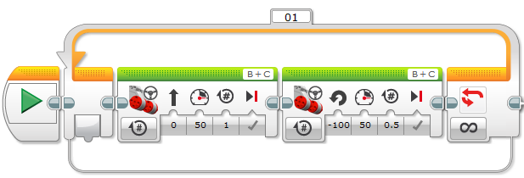

Page 4 of 5

Provide details on what the difference is between the following program loop and the previous program loop?
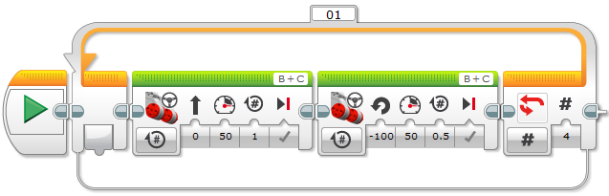

Provide details on what the difference is between the following program loop and the previous program loop?
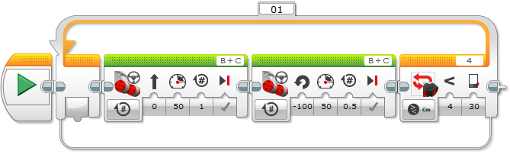

❐ Loops 7: Watch/Do/Show Teacher Container Handling Challenge

Upon completion of the Decisions-Loops module 1-6 & C, you should have the following programs in a project titled “LastName_LOOPS” (you should also update your program documentation file with a new slide titled LOOPS containing the programs, pictures and a detailed description for each maneuver):

❐ Square Lap 1  Square Lap 2  Square Lap 3
❐ Container Handling Challenge
Page 5 of 5

Provide details on what the difference is between the following program loop and the previous program loop?
Page 5 of 5

Provide details on what the difference is between the following program loop and the previous program loop?

❐ Loops 7: Watch/Do/Show Teacher Container Handling Challenge

Upon completion of the Decisions-Loops module 1-6 & C, you should have the following programs in a project titled “LastName_LOOPS” (you should also update your program documentation file with a new slide titled LOOPS containing the programs, pictures and a detailed description for each maneuver):

❐ Square Lap 1  Square Lap 2  Square Lap 3
❐ Container Handling Challenge
Page 5 of 5

