Google search EV3 ROBOTICS ACADEMY
Click on the link to go to “Introduction to Programming”
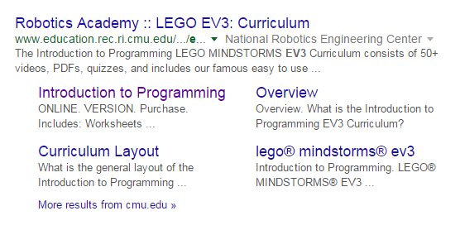
Next, click on the “Getting Started” module and finish the worksheet.
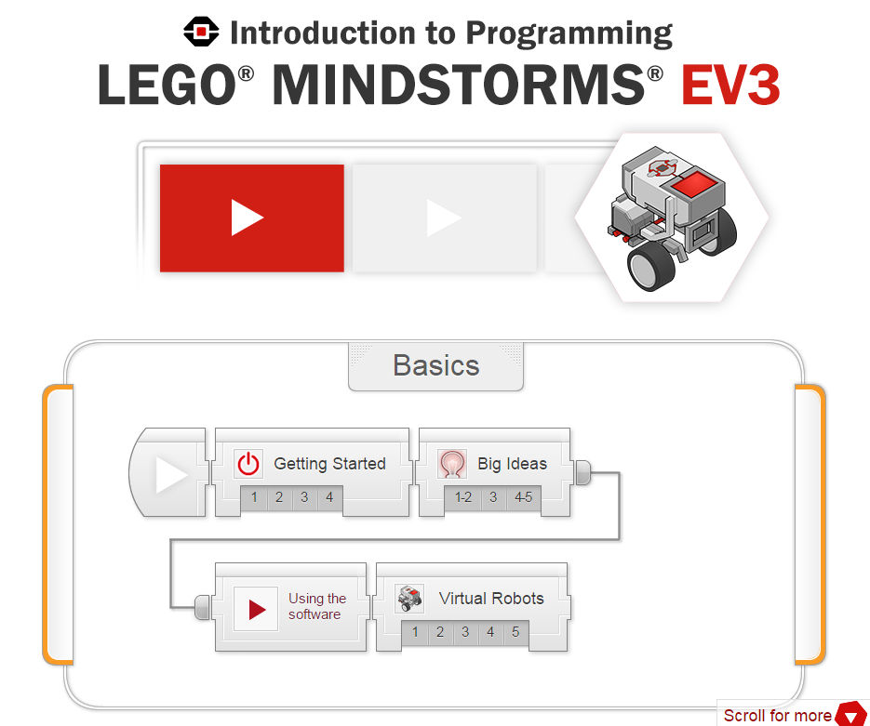
Check the boxes ✓ as you finish each task.
Getting Started 1: Batteries
❐ Watch the video “Batteries”.
Check Your Understanding:
1. Which of the following CANNOT be used for providing power the EV3?
- 6 AA batteries
- 6 AAA batteries
- EV3 Rechargeable DC Battery
- The EV3 accepts any of the sources listed above
Page 1 of 4
Getting Started 2: Downloading Firmware
❐ Watch the video “Downloading Firmware”.
Check Your Understanding:
1. What is Firmware?
- A special type of software that allows the EV3 to understand the programs you write
- A special type of software used by law firms
- The parts of the robot that are not flexible
- The physical appearance of the robot

2. What software do you use to download firmware onto the robot?
- The special EV3 Firmware Downloader app for mobile phones
- The Introduction to Programming: LEGO MINDSTORMS EV3 curriculum software’s.
- The EV3 Programming Software
- The firmware can only be updated at the factory

3. Where in the software is the option to download firmware?
- In the Tools Menu, under Firmware Update
- On the main menu, as a button marked "Download Firmware"
- In the EV3's on-screen menus, under "Firmware Tools"
- In the lesson pages

4. How do you turn on the EV3?
- Left Button
- Right Button
- Center Button
- Top Button

Getting Started 3: Ports
❐ Watch the video “Ports”.

Page 2 of 4
Check Your Understanding:
1. Motor (output) ports are identified using ______.
- Numbers 1, 2, 3, and 4
- Letters A, B, C, and D
- Numerals I, II, III, and IV
- USB and PC Ports

2. Sensor (input) ports are identified using ______.
- Numbers 1, 2, 3, and 4
- Letters A, B, C, and D
- Numerals I, II, III, and IV
- USB and PC Ports

Getting Started 4: Menus
❐ Watch the video “Menus”.
Check Your Understanding:
1. How do you turn on the EV3?
- Press the Back button and hold it for 5 seconds
- Press and hold the Left and Right buttons for 5 seconds
- Press and hold both the Center button and Back button
- Press the Center button

2. How do you turn off the EV3 properly?
- Remove the rechargeable Li-Ion battery pack
- Press and hold the Left and Right buttons for 5 seconds
- Press the Back button until a Shut Down dialog box appears, then selecting the check with the Center button
- Insert the Shut Down USB adapter into the USB port on the side of the EV3

3. How do you navigate the menus of the EV3?
- Touch the screen with an included stylus pen
- Use the LEGO IR remote
- Use the direction buttons to navigate, Center button to select, and Back button to cancel or go back.
- Use the Sound sensor and the built-in voice commands
Page 3 of 4
4. To run a program from the Run Recent menu, what do you do?
- Run Recent (first tab) > Select the program then press the center button
- File Navigation (second tab) > Select the Project > Select the Program
- Brick Apps (third tab) > Port View > Select the motor or sensor that you just recently used to run that program
- Settings (fourth tab) > Brick Info > Recently Run, then use the center button to select

5. To run a program from the File Navigation menu, what do you do?
- Run Recent (first tab) > Select the program then press the center button
- File Navigation (second tab) > Select the Project > Select the Program
- Brick Apps (third tab) > Port View > Select the project that is linked to available sensors and motors
- Settings (fourth tab) > Brick Info > Projects, then use the center button to select the programs

6. How do you check the motor and sensor values on the EV3?
- Plugging the EV3 into the computer and using the EV3 Software to check
- Using the Brick Apps (third menu) > Port View > Select the motor or sensor you want to view
- Adding a block to display the motor/sensor value when running a program
- Attaching a second screen adapter to the USB Port on the side of the EV3

7. Where can you find the speaker volume and other settings on the EV3?
- On the back of the EV3
- In the Settings (fourth tab) menu
- Behind the battery pack
- On the EV3 Software
Page 4 of 4

