Google search EV3 ROBOTICS ACADEMY
Click on the link to go to “Introduction to Programming”
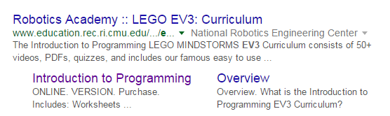
Next, click on the “Big Ideas” module and finish the worksheet.
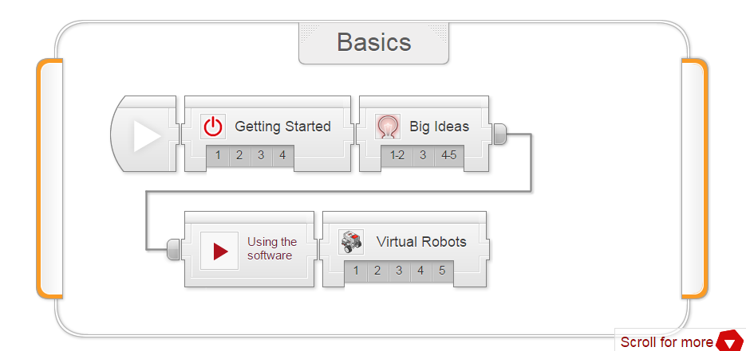
Check the boxes ✓ as you finish each task.
Ideas #1 and 2
❐ Watch the video “Big Ideas 1 & 2”.

Check Your Understanding:
1. What does the video mean by, "Programming is Precise"?
- The robot will always move to the precise location you want
- You need to tell the robot precisely what to do, or it might not be what you wanted
- If you do not type the commands exactly as shown, the program will crash
- The robot will do precisely what you want, even if you give it the wrong command

Page 1 of 5
Page 2 of 5
2. What do Sensors do for a robot?
- Provide power to onboard electronics
- Create a physical effect like turning a wheel
- Processes data and makes decisions
- Give it data on its position and surroundings

3. What does a robot's Program do?
- Provide power to onboard electronics
- Create a physical effect like turning a wheel
- Process data and make decisions
- Give it data on its position and surroundings

4. What kinds of Actions can a robot typically take?
- Provide power to onboard electronics
- Create a physical effect like turning a wheel
- Processes data and makes decisions
- Give it data on its surroundings

5. The hexarotor can maintain its position in the air by monitoring its own motion, calculating whether its position is steady, and adjusting motor power values to make sure it stays in place. This is an example of...
- Sensing
- A program running
- Acting
- All of the above

Idea #3
❐ Watch the video “Big Ideas 3”.

Check Your Understanding:
1. What kind of Model is the video talking about?
- A "mental model" – a systematic understanding of the way something works
- A design for a LEGO robot "model"
- A tiny "model" version of the real robot
- A "model" who appears in professional photography

2. What advantage(s) does a "model"-based understanding have over just memorizing facts?
- You can learn a "model" faster than memorizing every single fact
- You can reason about new situations, even ones you haven't seen before
- Models make things make sense
- All of the above

3. What is the "Program Flow" example in the video a model of?
- Unrelated blocks in the programming software
- Proportional reasoning
- The way a program runs
- Sensing, Planning, and Acting

Ideas #4 and 5
❐ Watch the video “Big Ideas 4 & 5”.

Check Your Understanding:
1. What does the video mean by, "Break down problems"?
- Split up a big problem into smaller ones that are easier to solve
- Solve the problem all at once
- Give up because the big problem is too hard
- Technical difficulties with the robot

2. What does the video mean by, "Build up Solutions"?
- Build a fully working solution by expanding upon partial solutions
- The best programs solve every problem at the same time
- Build your robot starting with the wheels and working your way upward
- Accumulate a lot of chemical compounds

3. Which of the following is NOT true about Computational Thinking?
- It is applicable outside of computer programming
- It includes the idea of using models to understand systems
- It is used in robotics
- It refers only to the process of writing code for a program
Page 3 of 5
Next, click on the “How to Use the Software” module and finish the worksheet.

How to Use the Software
❐ Watch the video “Using the EV3 Programming Software”.

1. Where can robot building instructions be found?
- The EV3 set comes pre-assembled in the only supported configuration
- In the EV3's firmware menus
- In the printed manual that came with the EV3 Set
- In the Robot Educator section of the EV3 Education Programming Software

2. Most project files will contain:
- Over 18,000 different programs in 19 different languages
- Other Project files
- A single program, called Program
- Robot files3

3. Which of the following connection types allows you to download programs onto the robot?
- USB cable
- Ethernet cable
- IR connection
- Power cable

Page 4 of 5
4. On the picture below, which button that loads the program onto the robot but does not immediately run it.
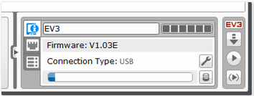
A
B
C
D
- A
- B
- C
- D

5. Which of the following will help you navigate around a large program?
- Scroll arrows on the sides of the screen
- Zoom controls in the top-right corner of the window
- Arrow keys on the keyboard
- All of the above

6. How do you add a comment to your program?
- Start typing on the keyboard and a comment will automatically appear
- Click the comment tool to create a comment box, then type in the box to add a comment
- Right-click a box and select Add Comment
- The EV3 software does not suppose adding comments

Page 5 of 5
4. On the picture below, which button that loads the program onto the robot but does not immediately run it.
A
B
C
D
- A
- B
- C
- D

5. Which of the following will help you navigate around a large program?
- Scroll arrows on the sides of the screen
- Zoom controls in the top-right corner of the window
- Arrow keys on the keyboard
- All of the above

6. How do you add a comment to your program?
- Start typing on the keyboard and a comment will automatically appear
- Click the comment tool to create a comment box, then type in the box to add a comment
- Right-click a box and select Add Comment
- The EV3 software does not suppose adding comments

Page 5 of 5

