Quiz
Sights, Sounds and Gears
Name:_________________________ Period:___ Date:________ Score:_____/35

- (3 pts.)What is a threshold?
- (3 pts.)Why must some thresholds be calculated rather than measured?
- (3 pts.)Your light sensor is reading a value of 16 in an environment where 8 was considered dark and 26 was considered light. Will your robot recognize the present reading of 16 as light or dark? Why?
- (2 pts.)Why is a sound sensor mounted so high on a tribot?
- (3 pts.)The starting gun registers 100 on the sound sensor while the quiet crowd registers 24. What should the sound sensors threshold be set at? Show your work.
- (3 pts.)If a motor in a two-gear tribot is attached to an 8 tooth driving gear, and the wheel is attached to a 24 tooth driven gear, what is the gear ratio? Is this an example of gearing up or gearing down?
- (3 pts.)When might you want to gear up your robot? Give an example.
- (3 pts.)When might you want to gear down your robot? Give an example.
- (3 pts.)The program below has a tribot move on the floor and stop on a line. Is the floor dark or light? If the line registers as 60 on the light sensor, what is the reading over the floor?
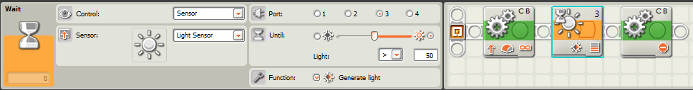
- (3 pts.)This “Clap-on, Clap-off” program uses a sound threshold >50 for the first Wait-until-Sound block (as shown) and <50 for the second Wait-until-Sound block (not shown) . Explain why this program may not work as intended.
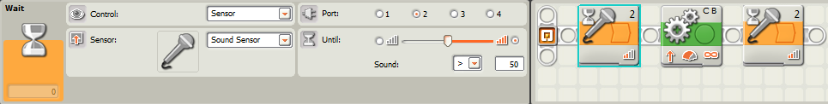
- (3 pts.)Ziffle writes a tribot program that will wait for the lights in the room to be turned off, then say “Have a Nice Day” and drive backward into its corner of the room for 15 seconds. Upon trying the program, Ziffle is disappointed to learn that the tribot’s parting words are hard to hear. What two changes to the Sound block could Ziffle make that would allow the tribot to be better heard?
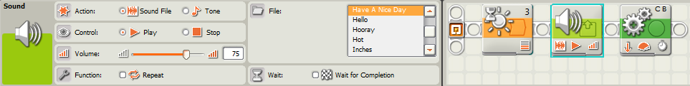
- (3 pts.)Ziffle then writes a program that will wait for the lights in the room to turn back on and have the tribot drive forward out of its corner in the room and stop as soon as it hears a clap within the first minute. Ziffle sets the light and sound thresholds correctly, but once again is surprised and disappointed by the results. What happens when Ziffle tries the program? What needs to be changed to get the desired results?
