Quiz
See, Touch, Repeat
Name:_________________________ Period:___ Date:________ Score:_____/30

- (3 pts.) How does the NXT detect when the Touch Sensor is pressed?
- (3 pts.) How does the Ultrasonic Sensor detect distance?
- (2 pts.) What is a threshold?
- (2 pts.) What mathematical comparison defines near vs. far for an Ultrasonic Sensor?
- (3 pts.) How does a loop block work?
- (2 pts.) How frequently is the Loop Block able to check its Condition to see whether it should exit?

- (3 pts.) Explain why an Ultrasonic Senor Controlled Loop program in NXT Trainer can fail to stop for the obstacle in some circumstances.

- (3 pts.) Ziffle is afraid he is going to get detention for a week. He wrote the program below for his tribot to move slowly forward until it bumped into full soda can, and then stop. To his dismay, when he ran the program, the tribot continued to move after contacting the can, pushing it off the table and causing it to burst on the floor. Why did his program not work as intended? Did Ziffle’s tribot also fall off the table into the sticky mesh on the floor? Why?
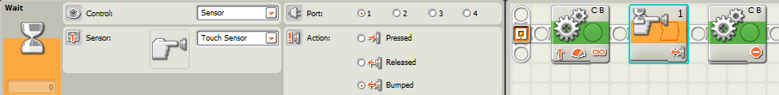

- (3 pts.) Ziffle decides never to make contact with a full soda can again, so he uses the Ultrasonic Sensor instead. If fact, he decides he will only approach the can when the tribot is over a foot away. He writes the following program and places the tribot facing the soda can, two feet away. What happens when Ziffle runs his program? Why?
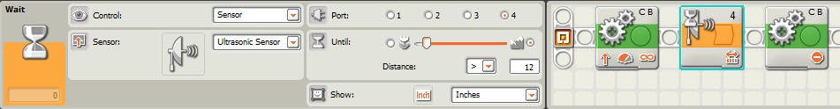
- (4 pts.) Ziffle writes the sentry program below to travel one lap round a rectangular field. Identify three different problems you can see in this program that he needs to fix.
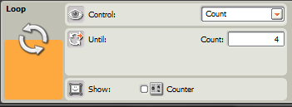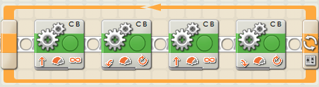
- (3 pts.) Ziffle writes the program below for his tribot to follow a zig-zag pattern and then stop/play a sound when it sees an obstacle less than 10 cm away. Assuming Ziffle has set all the parameters correctly (I know, that’s a big assumption for Ziffle), describe how his tribot responds to an obstacle.
