- (3 pts.) How does a loop block work?
- (2 pts.) How frequently is the Loop Block able to check its Condition to see whether it should exit?

- (3 pts.) Explain why the Ultrasonic Senor Controlled Loop program in NXT Video Trainer failed to stop for the obstacle in some circumstances.
- (4 pts.) Ziffle writes the sentry program below to travel one lap round a rectangular field. Identify three different problems you can see in this program that he needs to fix.
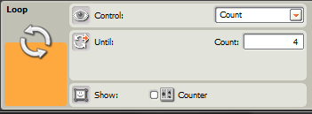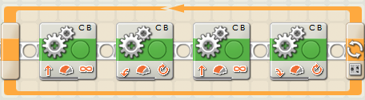
- (3 pts.) Ziffle writes the program below for his tribot to follow a zig-zag pattern and then stop/play a sound when it sees an obstacle less than 10 cm away. Assuming Ziffle has set all the parameters correctly (I know, that’s a big assumption for Ziffle), describe how his tribot responds to an obstacle.
