Quiz
Decisions, Decisions…
Name:_________________________ Period:___ Date:________ Score:_____/30

- (2 pts.) How do you know which branch is Near and which is far Far in an Ultrasonic Sensor controlled Switch Block?
- (3 pts.) Is the Switch-Loop “special” in the Programming Software? For an Obstacle Detection program, what does the Switch-Loop do, and how does it do this?
- (2 pts.) What happens if you change a Line Follower’s Loop Control Method to Time? Propose one possible use for this modified behavior.
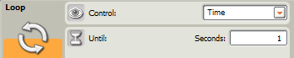
- (3 pts.) Besides time, what are 3 other ways to
control a Line Follower’s Switch-Loop?
- (3 pts.) Explain the role of the Switch Block in a Line Follower’s Switch-Loop.

- (2 pts.) What is the difference between Basic Line Following and Optimized Line Following? How do you implement both in NXT-G?
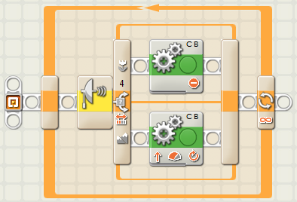
- (4 pts.) Ziffle writes this straight line Obstacle Detection program. What happens when the program is run? What does Ziffle need to do to improve it? Why?
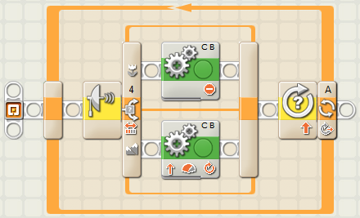
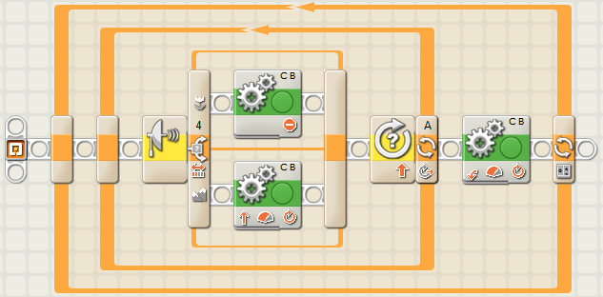
- (3 pts.) Ziffle fixes the previous problem with his Switch-Loop (not shown) and changes the Loop Control to “10 Rotations”. Assuming Ziffle fixed the previous problem, what happens when he runs this new program. Why?
- (4 pts.) Ziffle fixes both previous problems with his Switch-Loop (not shown), then he adds a 90 degree turn and an outer Counter Controlled Loop so the tribot will travel in a square. Assuming Ziffle fixed the previous problems in his Switch-Loop, what happens when he runs this new program. Why?
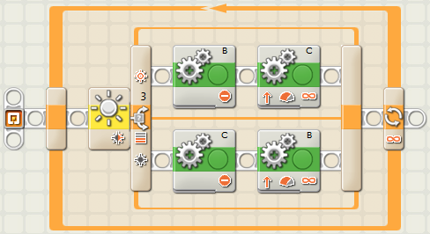
- (4 pts.) Ziffle writes this Line Follower program to track a gently curving line. Much to everyone’s surprise, Ziffle’s program works quite well. Ziffle must now modify this program to work on two other courses. How should Ziffle modify his program to:
A) maximize speed on a straight course?
B) track a course with much sharper curves?

