Task Assignment
Engineering Challenge: Sumo-Bots

Sumo-Bot Match Procedures
This will be a double-elimination competition.
This event will take place on a ~4’x4’ whiteboard with a black border. The arena will be a white square 36” on a side. The arena will be slightly elevated to facilitate timely conclusion of matches.
Sumo-bot wrestling will begin with opponents in opposite corners and will continue until either one opponent is completely out of the arena, or one Sumo-bot is disabled.
The match will begin with a countdown, followed by the student pressing the “Run” button on the brick or a touch sensor connected to serve as a remote “Run” button. After pressing “Run”, the student must step out of the “no-fly” zone (at least 3 feet from the arena).
If, after one minute, there is no clear winner, the competition will be halted. After a second, abbreviated “call to start” (30 seconds), an additional one minute re-match will begin. For the rematch, Sumo-bots will be placed back-to-back in the center of the arena and must move forward or turn (may not move backwards) immediately after the start of the match. If there is no clear winner after the re-match, judges will declare a winner based on which Sumo-bot is least disabled, or has most nearly pushed its opponent from the arena during the matches.
The winning robot must either push its opponent completely out of the arena (not counting appendages extending beyond 12”), or disable its opponent (render opponent unable to maneuver, while victor Sumo-bot still can). If a robot is not pushed off the mat, but is flipped, the flipped Sumo-bot is considered disabled and loses the match.
Sumo-Bot Specifications
Components: All robots will be constructed only from a single 9797 NXT kit (items as listed on the 9797 placards) or a single 45544 EV3 kit (items as listed on the 45544 inventory pdf) and the following additional allowed items:
(49.6 x 28 mm) or
(43.3 x 22 mm)
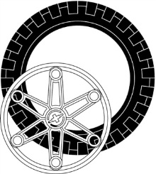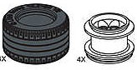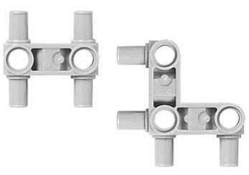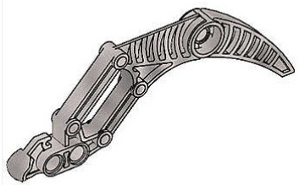
Large or Lawnmower Wheels (up to 2 each) Snap Beams (up to a total 10 each) Claw (up to 4)
Exceptions: EV3 Sumo-Bots may not use any of the black curved panels (parts #: 4543490, 4541326, 4566251, 4566249) or track pieces (part #6014648).
Size: All robots will fit inside a 12 inch cube, but may have appendages that extend out after competition begins.
Power: All robots will be powered by a LEGO NXT or EV3 rechargeable battery pack.
Software: All robots will be programmed by NXT-G, EV3-G, RobotC or NXC.
Design Modifications: Either hardware or software may be modified on the day of competition, provided the robot is ready to compete at its designated time.
Remote Control: Dragsters and Sumo-Bots are to run autonomously (with no remote control), not responding to any student input after the “Run” button is pressed. Line Racers may use only wired-remote controls. In no case is wireless robot control allowed.
Engineering Challenge: Sumo-Bots

- Use the Engineering Process to develop your Sumo-Bot.
  - The Commercialization step will be the Sumo-Bot competition.
- For each of the other steps of the Engineering Process, document your progress by completing the associated Deliverables and your Engineering Process Log.
- Have another team sign off on your deliverables before submitting them for grading (including all the elements for your Design Review).
- Present your Design Review for your classmates and teacher

Date | Deliverables | Sign-off
 | Requirements
 | Research Report
 | Design Concept
 | Project Plan
 | Design Review Elements
 | SUCCESSFUL SUMO-BOT DESIGN REVIEW!! | (Teacher)

