Task Assignment
Engineering Challenge – Cube Wrangler

Cube Wrangler Match Procedures
This will be a double-elimination competition.
This event will take place on a ~4’ X 8’ white board with 2 x 4 side walls (ala FLL), with a 1” dark blue painters tape (Lowes) Center Line (referred to as line 3 in image below), two parallel Goal Lines ~12” from the each end and two additional parallel lines (referred to as lines 1 & 2) randomly placed between the Center Line and the Goal Line on each half of the table. All these lines will be at least 6” from each other and symmetrical (approximately) about the Center Line. No-Score zones marked by a ~12” squares in each table corner will bracket Scoring zone.
A total of 5 FTC Block Party cubes will be placed on the board; 1 on each of the numbered lines and mirrored about the Center Line. Teams will compete for the cube placed on Center Line (line 3). Cubes will be randomly placed at least 6” from the side walls, holes facing up. Cube faces will be approximately centered on and orthogonal to the numbered lines. Cubes will be numbered 1, 2 or 3 on their flat sides.
Robots must always touch the team’s home side of the board. Robots that completely cross the center line will forfeit the match.
To start the match, robots must be placed completely in either of the No-Score zones, with program selected and waiting for center button to be pressed once, before officials place the cubes. Once robots are in position, cubes will be randomly placed by the officials, but mirrored across the Center Line.
The match will begin with a 3, 2, 1 countdown by the official. Each match will last 90 seconds. Once a robot has left the No-Score zone, it may return to either of the No-Score zones to change programs or reposition within the No-Score zone.
Any cube in the No-Score zone while the robot is being handled will be returned to the center of the line from which it came. If a robot touches any cube while being handled in the No-Score zone, the cube will be returned to the center line from which it came.
The object of the game is to move up to three cubes to the Score zone.
Scoring:
Cubes completely inside the Score zone (completely beyond the tape, not touching the tape; this is different than FLL scoring) will be scored at the end of the 90 second match.
- The cube from line 3 is worth 3 points.
- The cube from line 2 is worth 2 points.
- The cube from line 1 is worth 1 point.
Robots must only transport and score one cube at a time. If a robot appears to be intentionally transporting more than one cube at a time, all transported cubes will be placed in the center of their respective lines.
Multiplier: If a cube is stacked on top of another cube, the cube immediately below it is doubled in value.
Stacks must be freestanding in order to receive the multiplier. See Cube Multiplier Scoring Examples below.
Touch Penalty: A robot may be handled and returned to a No-Score Zone at any time, however any cubes being handled will be returned to the center line from which it came and a negative one-half point penalty will be assessed.
Tie Breaker: Should a tie occur, the first team to have placed a cube in the Score zone will win the match.
Example Set-up for Cube Wranglers Challenge
Line 1
Line 2
Line 3
Line 2
Line 1
Scoring
Zone
No Score Zone
No Score Zone
No Score Zone
No Score Zone
Scoring
Zone

Cube Multiplier Scoring Examples
3
1
1
2
2
1
2
3
1
3
10 Points
4 Points
9 Points
7 Points

Cube Wrangler Specifications
Components: All robots will be constructed only from a single 45544 kit (items as listed on the 45544 inventory) and the following additional allowed items:
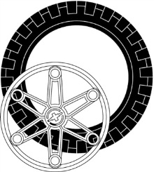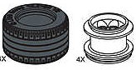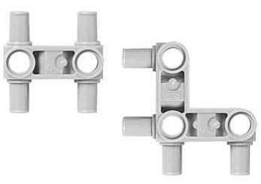

Large or Lawnmower Wheels (up to 2 each) Snap Beams (up to 8 each)
Size: All robots will fit inside a cube 12 inches on a side.
Power: All robots will be powered by a Lego rechargeable battery pack.
Design Modifications: Either hardware or software may be modified on the day of competition, provided the robot is ready to compete at its designated time.
Remote Control: Line Racers may use only wired-remote controls. In no case is wireless robot control allowed.
4th Motor Option: If no NXT’s are participating in the competition and supplies permit, a fourth motor may be used for the Cube Wrangler

- Use the Engineering Process to develop your Cube Wrangler.
  - The Commercialization step will be the Match.
- For each of the other steps of the Engineering Process, document your progress by completing the associated Deliverables and your Engineering Process Log.
- Have another team sign off on your deliverables before submitting them for grading (including all the elements for your Design Review).
- Present your Design Review for your classmates and teacher

Date | Deliverables | Sign-off
 | Problem Statement
 | Research
 | Design Plan
 | Prototype/Iterations
 | Commercialization
 | Successful Cube Wrangler Design Review | (Teacher)

